subject :

software development

title:SRS document for covid 19 trackers

CREATED BY:

PRIYADHARSHINI.N

PUNNAGAI.S

LEKHYA NINDRA

ANUSHA. PM

SRS DOCUMENT FOR COVID 19 TRACKERS

Objective:

Corona virus (COVID 19) is an murderous infectious disease.

Functional requirement:

* The objective of the APP STOP covid19 CAT and the covid19Xat is to offer the user a self assessment test on the systems of the covid19.
* In case of a possible covid19 case,the digital tools store the citizens data in order for the health services to be able to monitor his/her progress.
* The health services will assess the need to re-classify ,monitor,or alert the emergency services in case they needed.

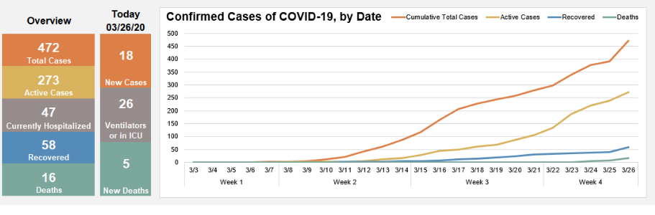

* The tabular column referred here is mentioned the number of the people affected by covid19 are differentiated by confirmed, active,diseased,recovered.

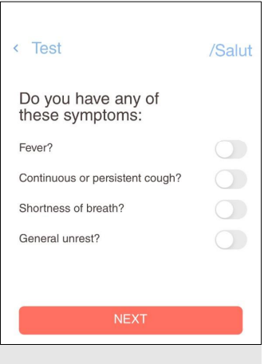

* In case of a negative answer to all questions,the application will consider it not necessary to conduct any further survey and it will urge the user to observe the precaution measures.



* The user’s telephone number is required to be able to contact the patient and keep their data updated.

Post condition:

Performance of covid19 tracker:

To detect the covid19

Availability:

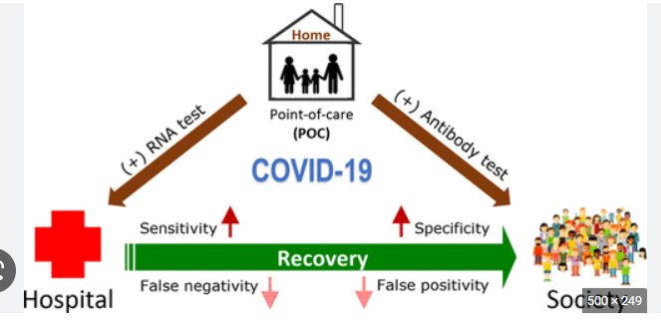

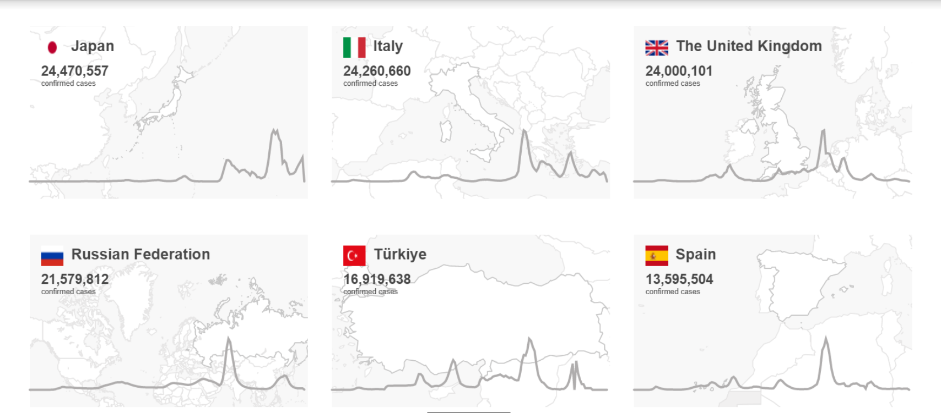

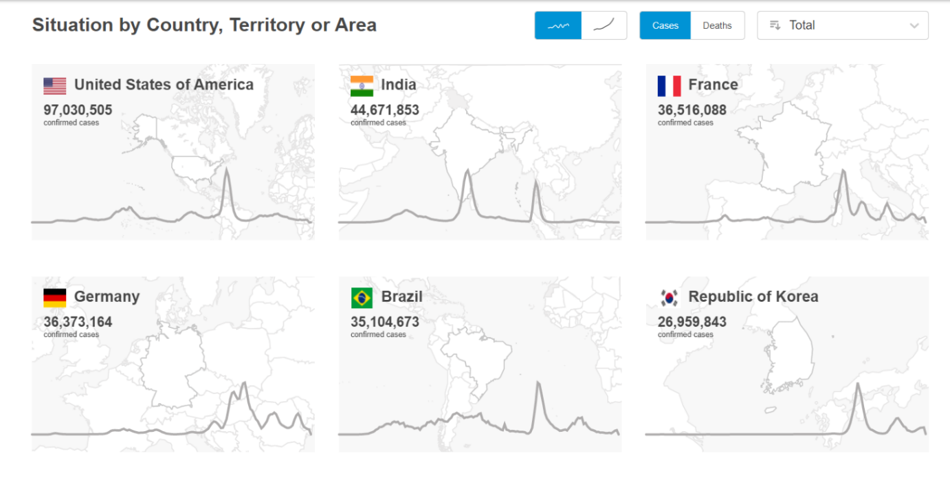

|  |  |  |
| --- | --- | --- |
| Total no of people | confirmed | Vaccinated or not |
| 15,000 | 9000 | 8000 |
| 25,000 | 15000 | 12000 |

Standard features:

Patients with typical clinical signs suspicious of covid19 such as fever,cough,sore throat,loss of taste or smell,malaise,amd myalgias should be properly tested for SARS-cov-2.

Technology stack:

* Latest technologists ,such as andIMT,drones,robots,UV’s,GPS,and Bluetooth can play a primary role in such circumstances to mitigate the impact of covid19 outbreak.
* The vaccines that offer the strongest protections,produced by Pfizer,and moderna,use mRNA technology to trigger an immune response.

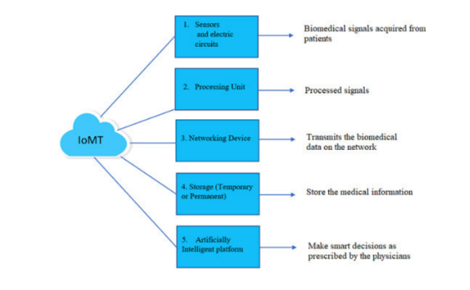

Assumptions about covid19:

We are long away from with this fight

* A study released last month by the scripps research institute concluded that the strains of the virus spreading so quickly in Europe and the US have a mutated “spike”protein that was initially identified in Asia.
* If it seems like the United states is having a tougher time controlling the spread of the coronavirus disease than Asian countries did in winter early spring,that’s partially because this version of the virus is tougher to stop from spreading.
* More and more researchers are that SARS covid is air borne,meaning that it is not merely being dispensed by the bodily fluids of those who have it I but also floating in aero solized form.
* It is also possible that the virus is not truly aerosolized but that is floating in tiny droplets which are so small and so light that they can easily be carried long distances by air currents.
* The European centre of disease prevention and world health organization are now taking the former possibility seriously.And with good reason.

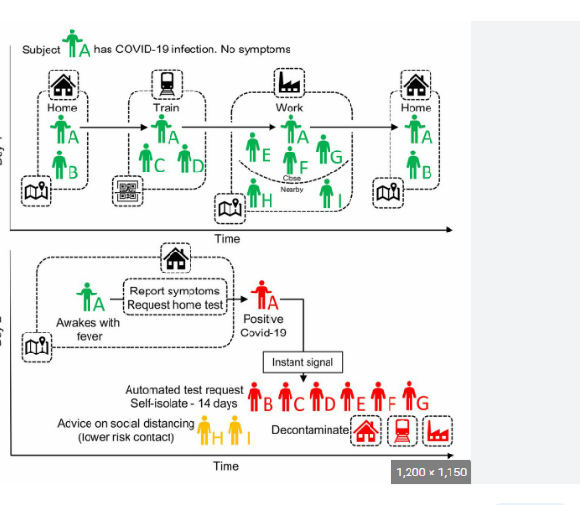

COVID 19 TRACKER APP:

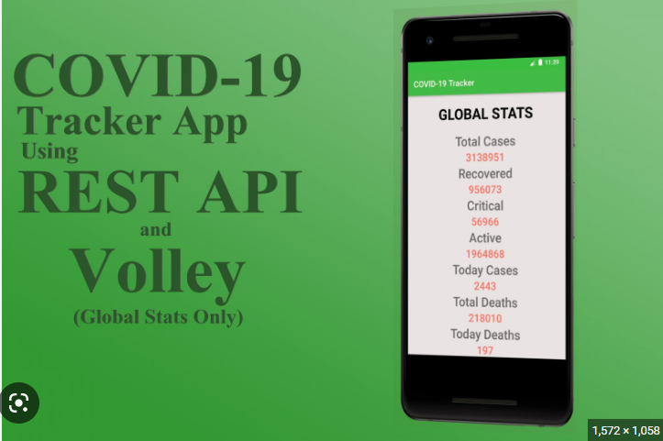



Symptom of corona:

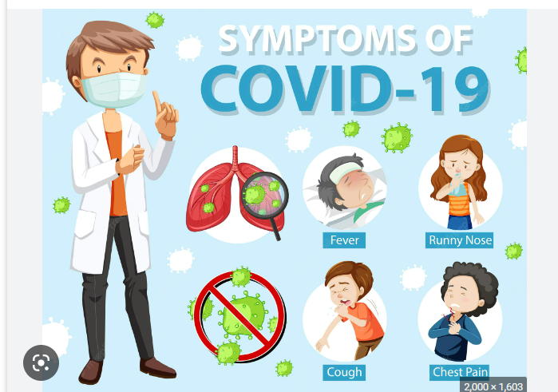

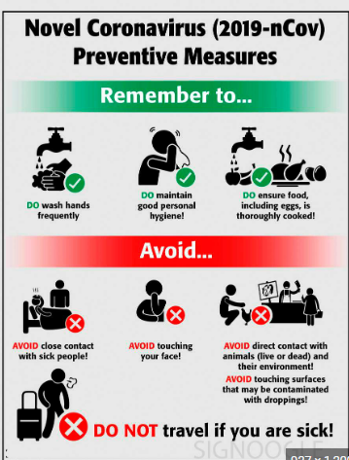

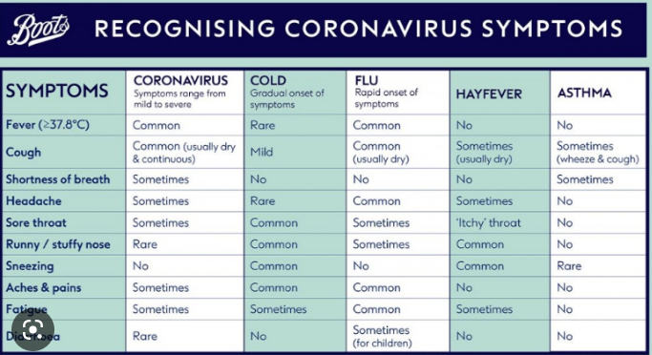

Prevention:

Wear a mask

Clean your hands

Maintain safe distance

Get vaccinated



